**Name: __________________________  
Date: ___________________________**

**Lesson 2-2: Surface Area of Cylinders and Spheres**

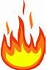**#4: How do I find the surface area of cylinders? #5: How do I find the *lateral* surface area of a cylinder?  
 #6: How do I find the surface area of a sphere?**

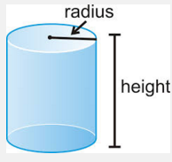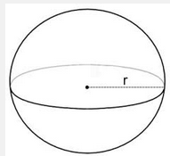**Warm Up** Name the figures below:

Figure 2

Figure 1

**Surface Area of a Cylinder**

What familiar polygons make up the net of a cylinder? So, what ***area*** formulas do we need?

So, how will we find the **total surface area** of a cylinder?

**Total SA of Cylinder =** _______________ + _______________ + _______________

= _______________________________

**Surface Area of a Sphere**

What familiar shape makes up a Sphere? So, then what ***area*** formula will we need?

**Total Surface Area of a Sphere =**

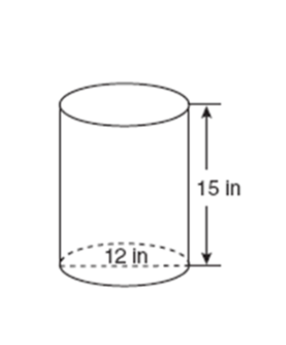**Let’s try it!**



**Watch Me!  
  
Example 1:** Find the total *surface area* of the following three-dimensional figure. Leave your answer in terms of pi.

**Example 2**: Find the surface areaof the *curved surface* of a cylinder with a radius of 5 feet and a height of 9 feet. Use appropriate units in your answers. Round to the nearest tenth.

How is this different from #1?

**Example 3:** Find the surface area of the sphere. Round your answer to the nearest whole number.

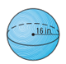

**Example 4:** The total surface area of a cylinder is 108 in2. The radius of the cylinder is 6in. What is the height of the cylinder?

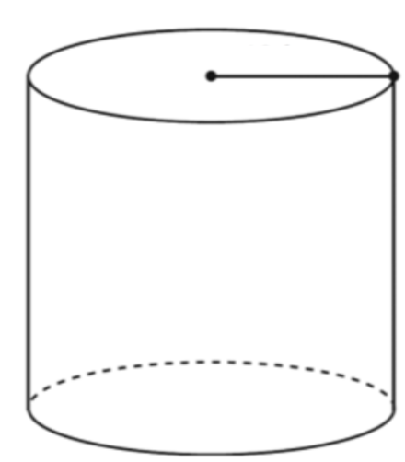

Why is this considered a   
 “working backwards” question?

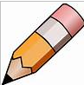**You Try!**

**Example 4:** **:**  Find the surface area of the sphere. Round your answer to the nearest whole number.

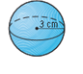

**Example 5:** Calculate the total surface area the cylinder below. Keep in terms of Pi.

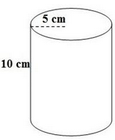

**Example 6:** Campbell Soup is creating a new soup label. If a can has a height of 6 in and a diameter of  
4 in, how much material does Campbell need for each soup **label**?

*\*Hint: Does the label cover the whole can?*

*What area(s) do we need to find?*

Round your answer to the nearest tenth of a square inch.

**Example 7:** Bob is asked to find the surface area (to the nearest tenth) of a sphere with a diameter of  
10 millimeters. **Explain** and **correct** his errors (there are two errors!).

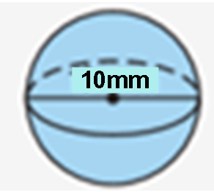SA = 42 = 42 =   
 = 3

**Hint!** Try answering the question first how you normally would, and then look to see if you spot any differences!

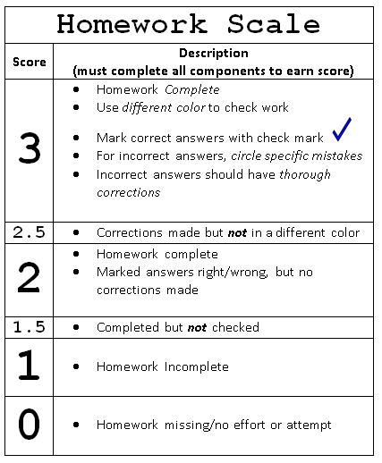**Name_____________________________  
Date _____________________________**

**Lesson 2-2: Homework**

1. The cylindrical tank shown in the diagram is to be painted. How many square feet of paintmust be used to complete the job? Round your answer to the nearest square foot.

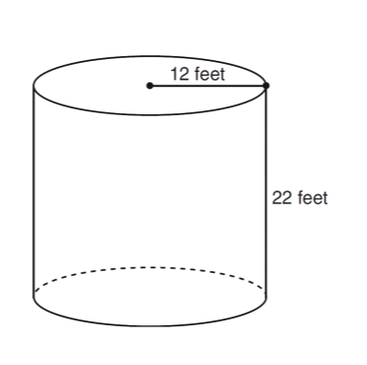

1. The total surface area of a sphere 100 cm2. What is the radius of the sphere?
2. Consider the figure below:
3. 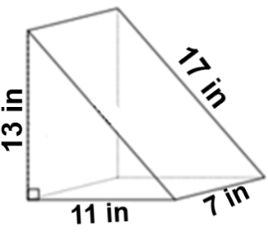What is the name of the figure? __________________________________
4. Draw and label the net.
5. Calculate the surface area:

Watch the assigned video fill in notes/answer questions as you go. Mastery of the content of this video is essential for you to understand in class. Content in this video is only covered in this assignment. I WILL NOT TEACH THIS CONTENT in a separate lesson during class. You can re-watch parts at any time and if you have questions.

**Video on Edpuzzle! Click the link in Google Classroom and sign in with “Google” button!**

**Learning Goal:** How can we calculate the surface area of a cylinder and a sphere?

**Surface Area of a Cone**

***What area formula(s) do you think we will need to find the surface area of a cone?***

**Careful!** Sometimes we are asked to***only find the lateral area*** instead of the ***total area!***

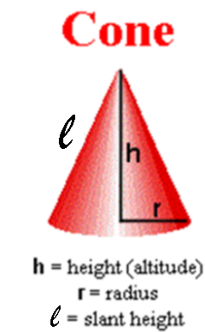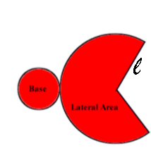**Net**

**Total Surface Area of a Cone**

**Total SA = ___________ + ___________**

**= ___________ + ___________**

**Let’s try it!**

|  |  |
| --- | --- |
| **Watch Me!  Example 1:**  Calculate the **lateral surface area** of the given solid. Round to the nearest tenth. | **You Try!  Example 2:** Calculate the **total** **surface area** of the given cone. Round to the nearest tenth. |